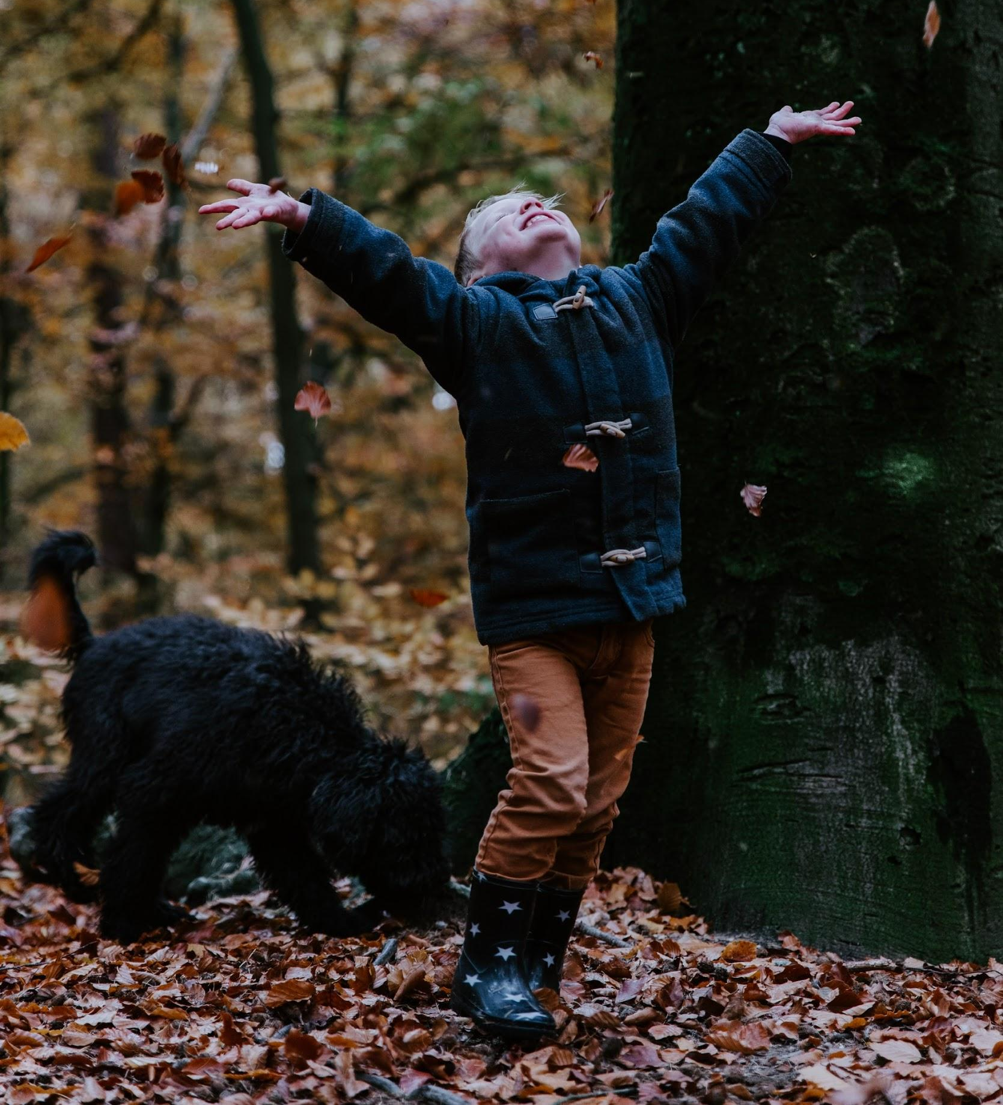

Outdoor Play: A Prescription for Better Health
Kids are spending less time outside than ever before. Screens commonly take the blame, and there’s no doubt they’re partly at fault: The average child is in front of screens for nearly one-third of the day. However, screens aren’t the only thing keeping kids indoors. Between their busy schedules, homework, technology, and worried parents, the average child spends less than 10 minutes a day playing outside.

Why Too Little Nature is a Bad Thing
- What is nature-deficit disorder?
- The unexpected effects of all that screen time.

Nature and Your Child’s Health
- How does nature impact our well-being?
- Top 5 benefits of children playing outside.
- 10 reasons why kids need to spend time outdoors.

What’s Keeping Kids Indoors?
- How to help your kids with their technology addiction.
- Children should play outside alone — here’s how.
- We need to stop worrying and just let our kids play.

Giving Kids a Reason to Get Outdoors
- How kids can make neighborhood friends.
- 14 easy ways to make your backyard more fun.
- Home science: backyard astronomy basics.
- 5 reasons why a bike is the best gift you can give a kid.

How to Get Outside as a Family
- Family walking: a tradition that grows as your kids do.
- 10 tips for planning a camping trip with kids.
- 4 tips when mountain biking with your child.
- Outdoor safety tips for hiking with kids.

Staying indoors may seem safer, but the truth is that kids have a lot to gain from outdoor play. Time in nature inspires confidence and creativity in children while improving their physical and mental well-being. For healthier, happier kids, the prescription is clear: Get outside!

Image via Unsplash

